Installation Guide

The following will be the necessary steps you should take to install XAMPP. We will be using XAMPP for MySQL and PHP.

Step 1. Download XAMPP

To install XAMPP go to <https://www.apachefriends.org/download.html> and click on the version for your operating system. For this project we downloaded the 7.2.34 / PHP 7.2.34.

Step 2. Run .exe file

Once downloaded, find the software bundle in the downloads folder, and double click to run it.

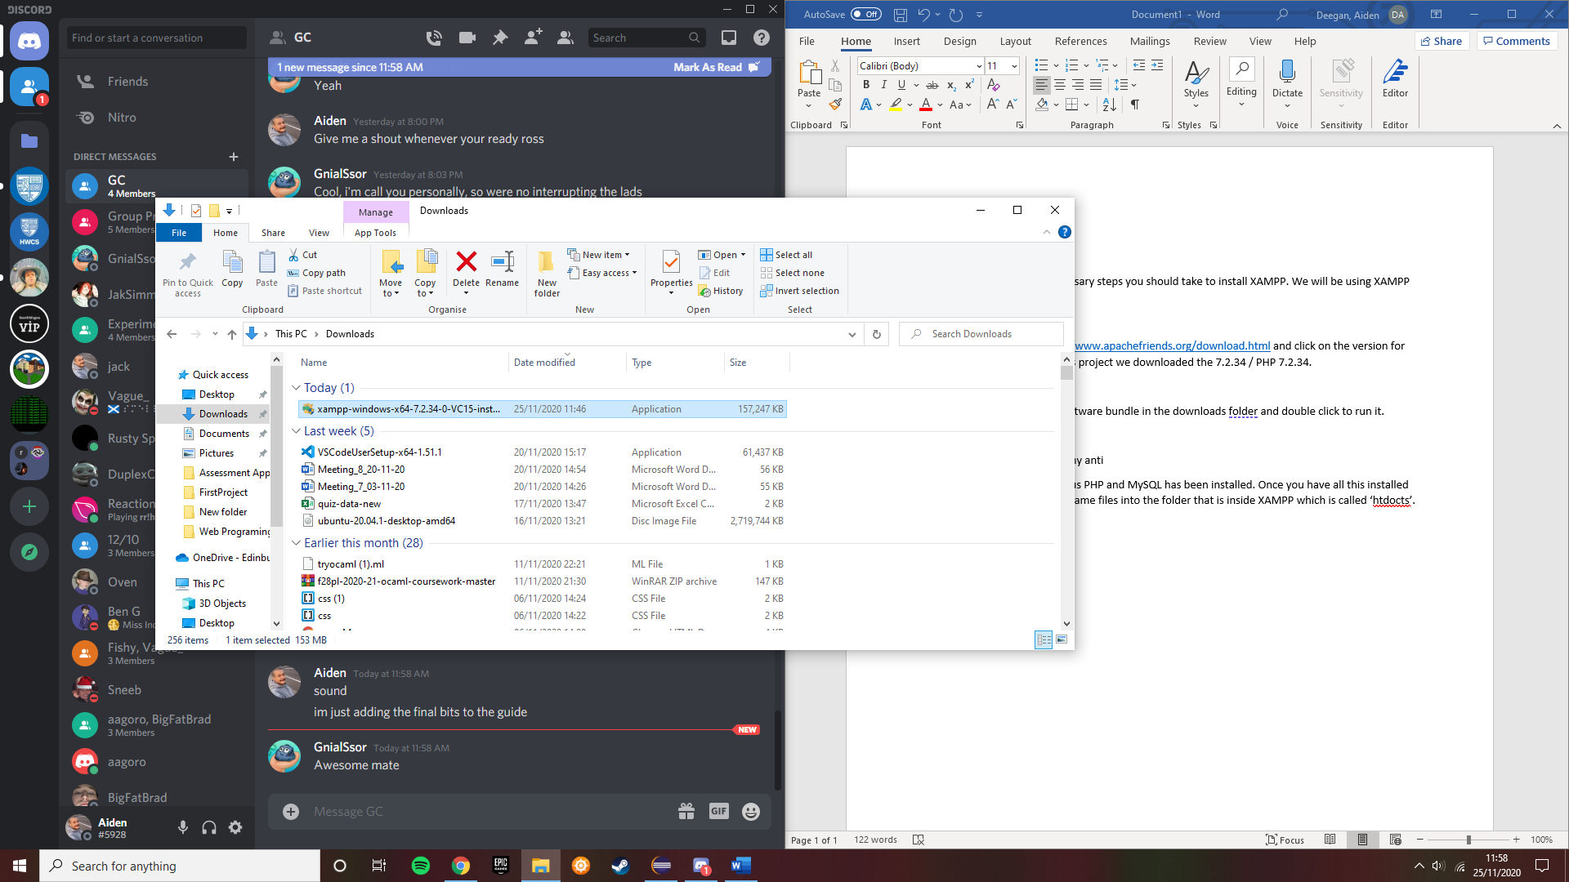

Step 3. Deactivation

When its running deactivate any antivirus software and deactivate the UAC.

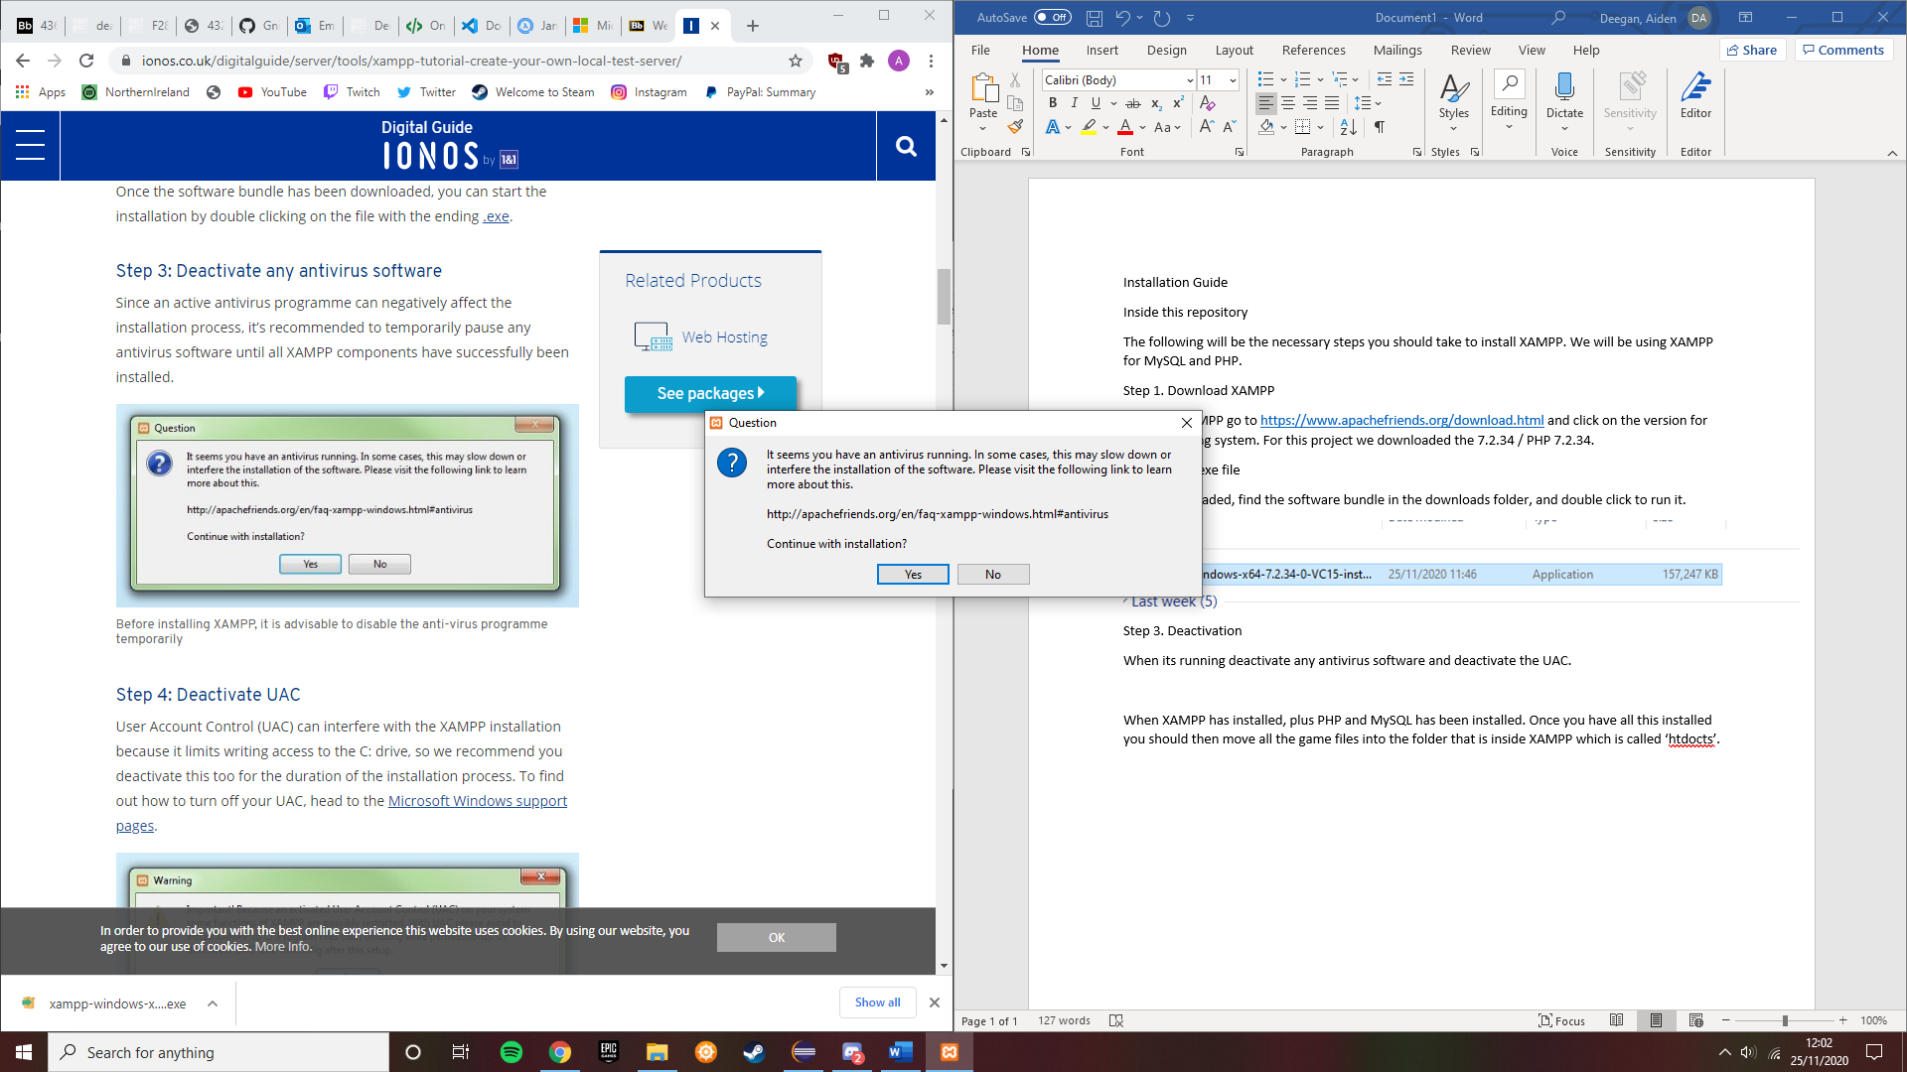

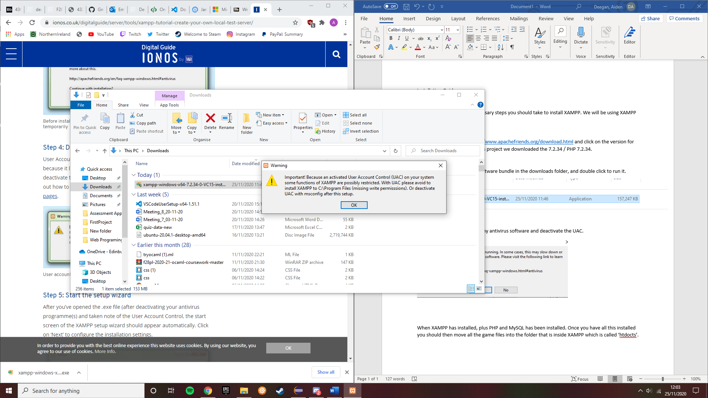

Step 4. Start the stetup wixard

This should just pop up after the previous steps. Just click next to continue.

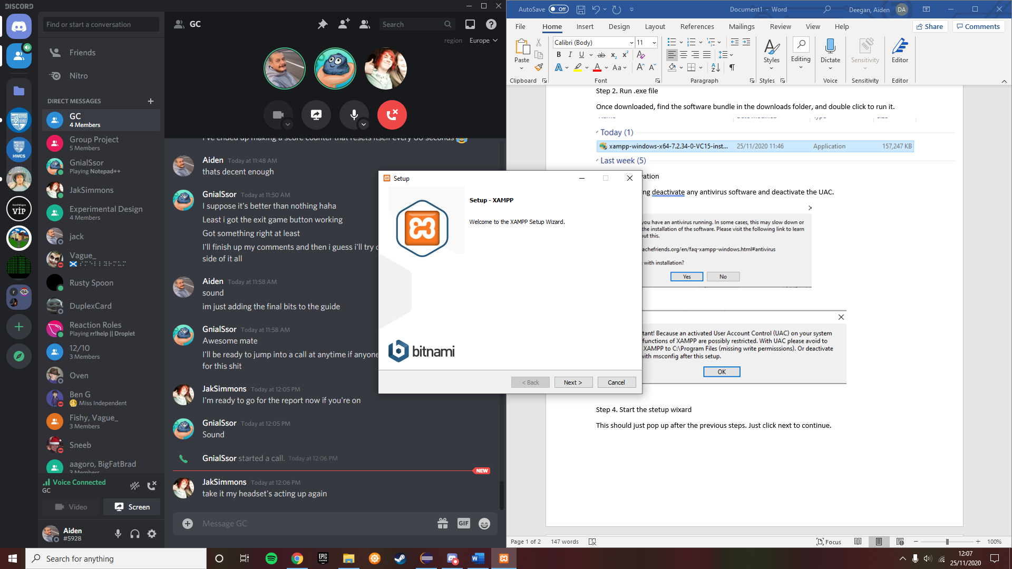

Step 5. Choose what software components to install

I recommend installing everything as it will allow for future extensions. The PHP version that it will download will be 7.4.11. This version will be sufficient for our project.

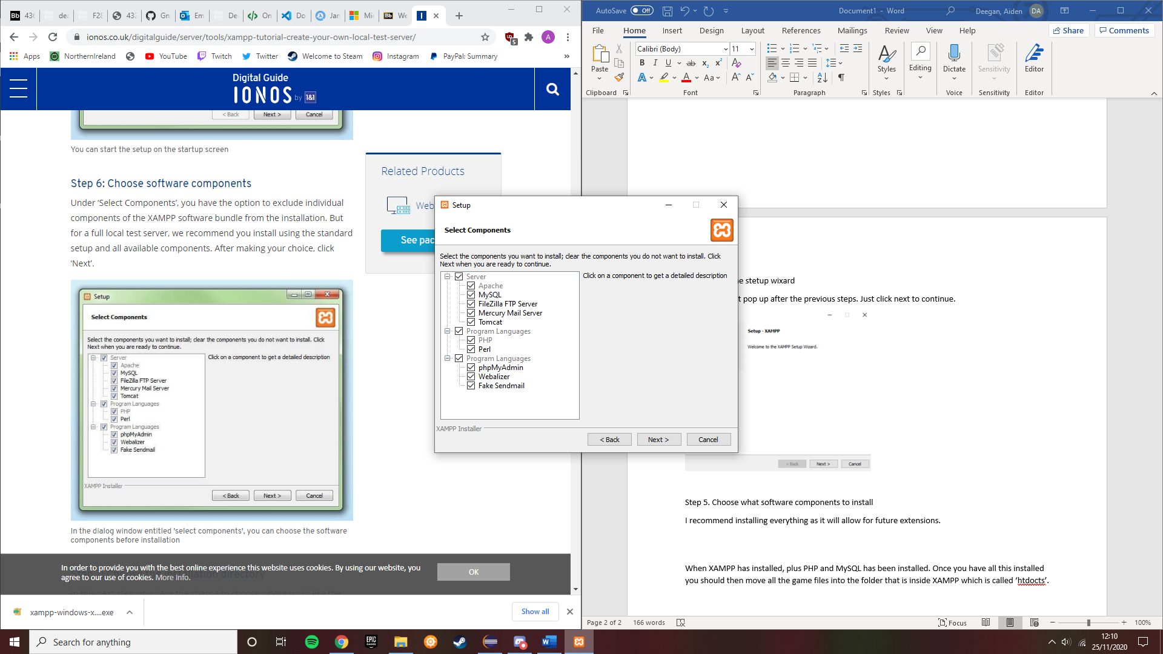

Step 6. Choose the directory you wish to store XAMPP

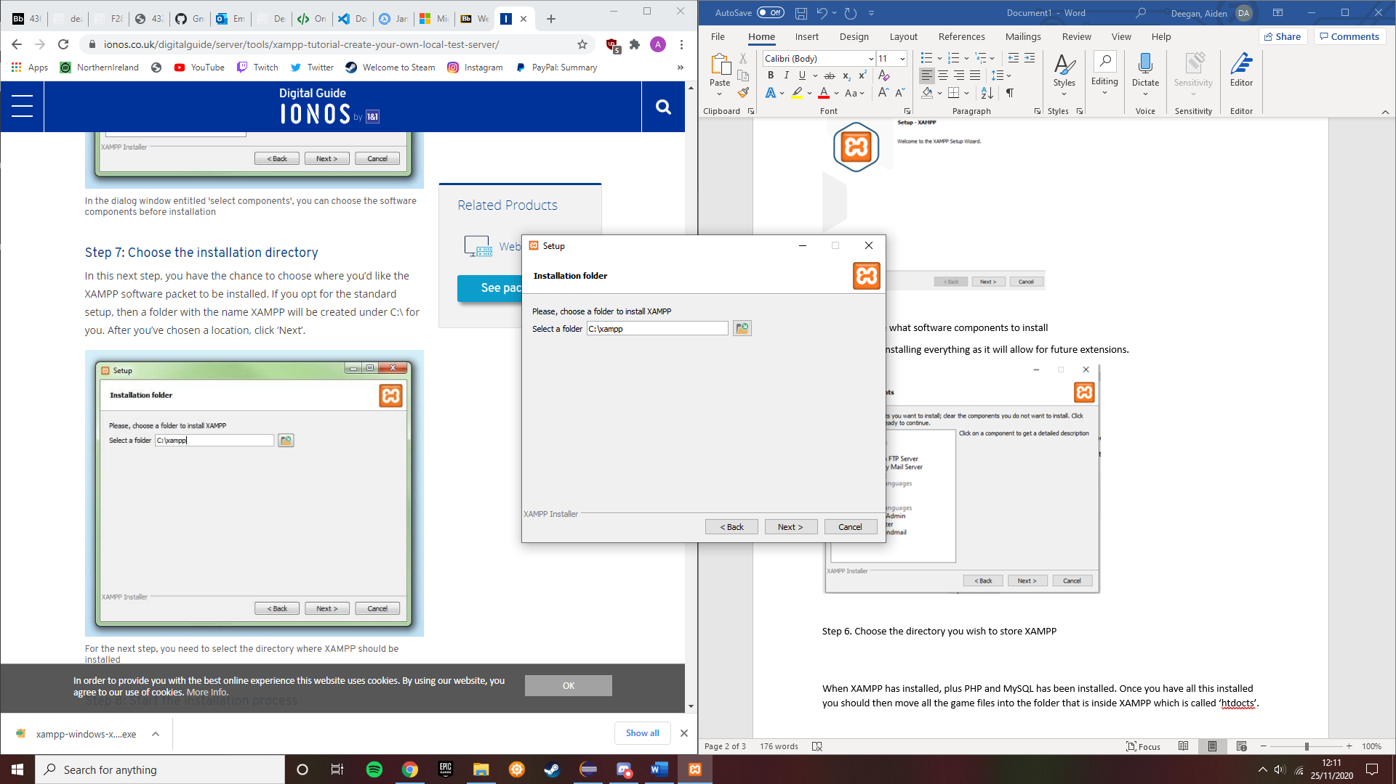

Step 7. Choose what language you want to use.

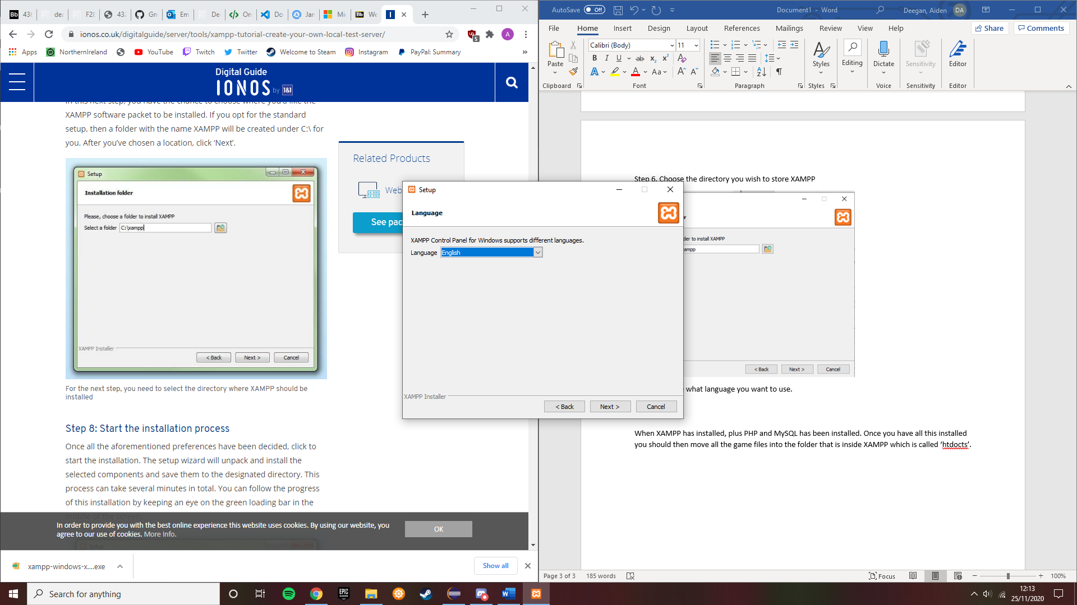

Step 8. Start the installation

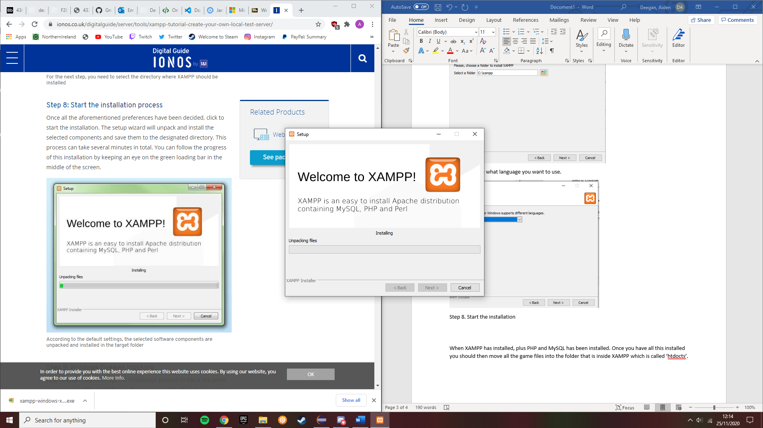

Step 9. Allow Access through Firewall

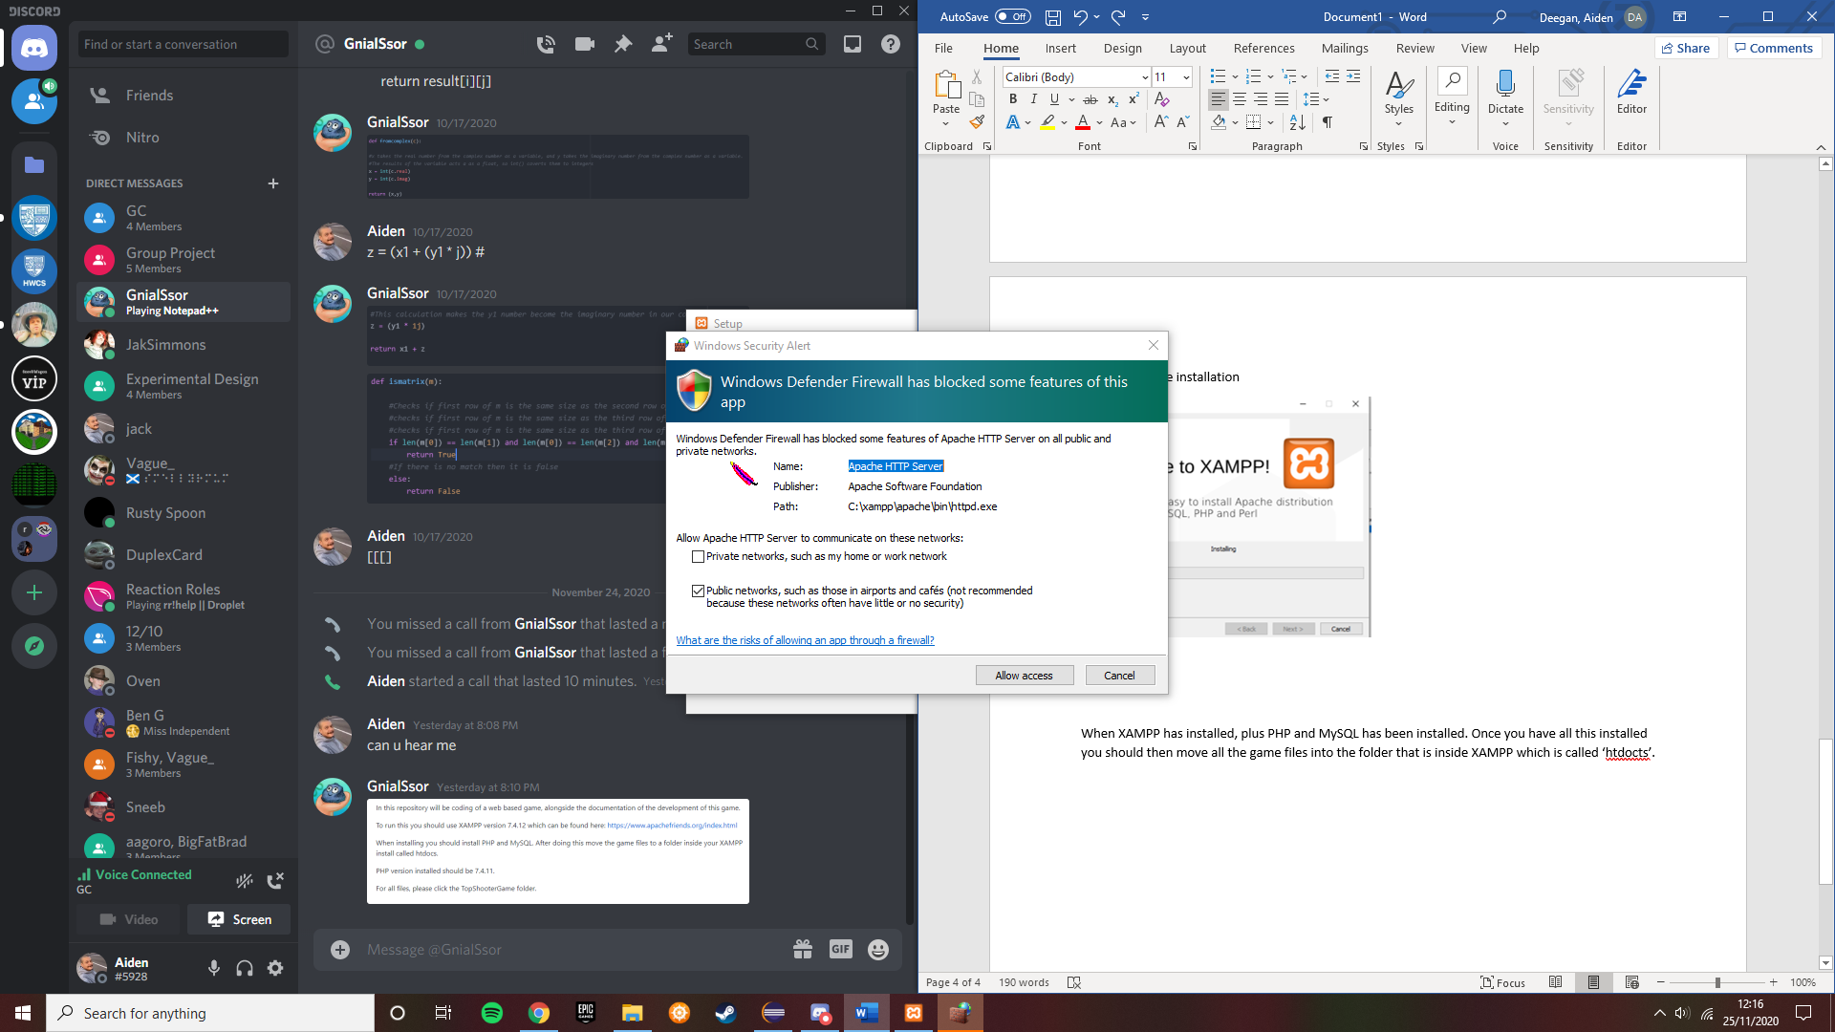

Step 9. Finish the installation

Just simply click finish and XAMPP should be installed. 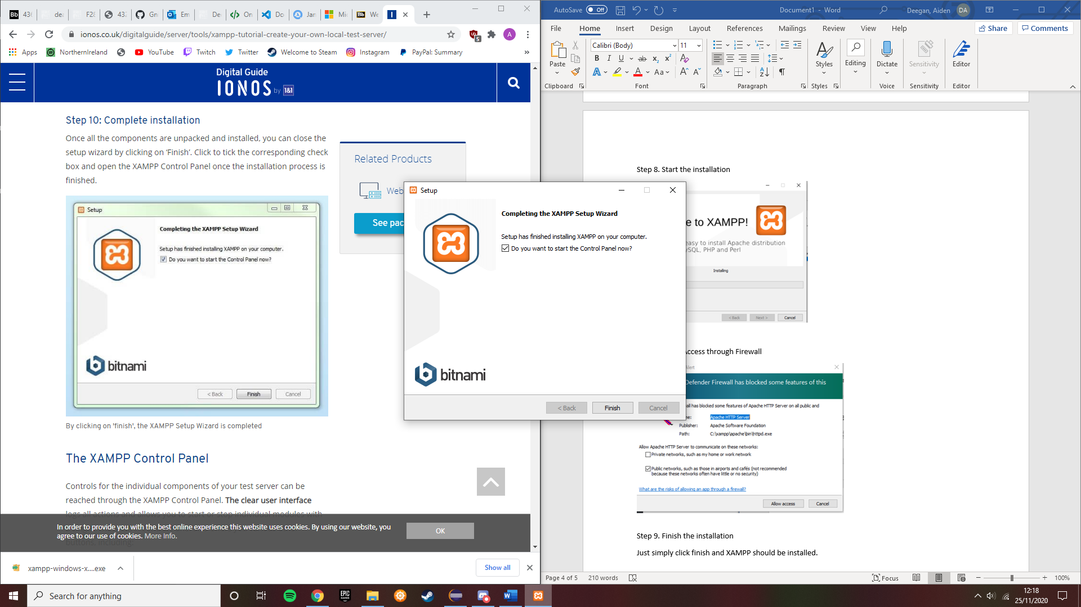

When XAMPP has installed, plus PHP and MySQL has been installed. You should then move all the game files into the folder that is inside XAMPP which is called ‘htdocs’. To access the folders within XAMPP, run the task manager and click on XAMPP. It should launch the XAMPP control panel. Click on the explorer button that has the folder icon next to it then navigate to ‘htdocs’. This is where your game files will go.

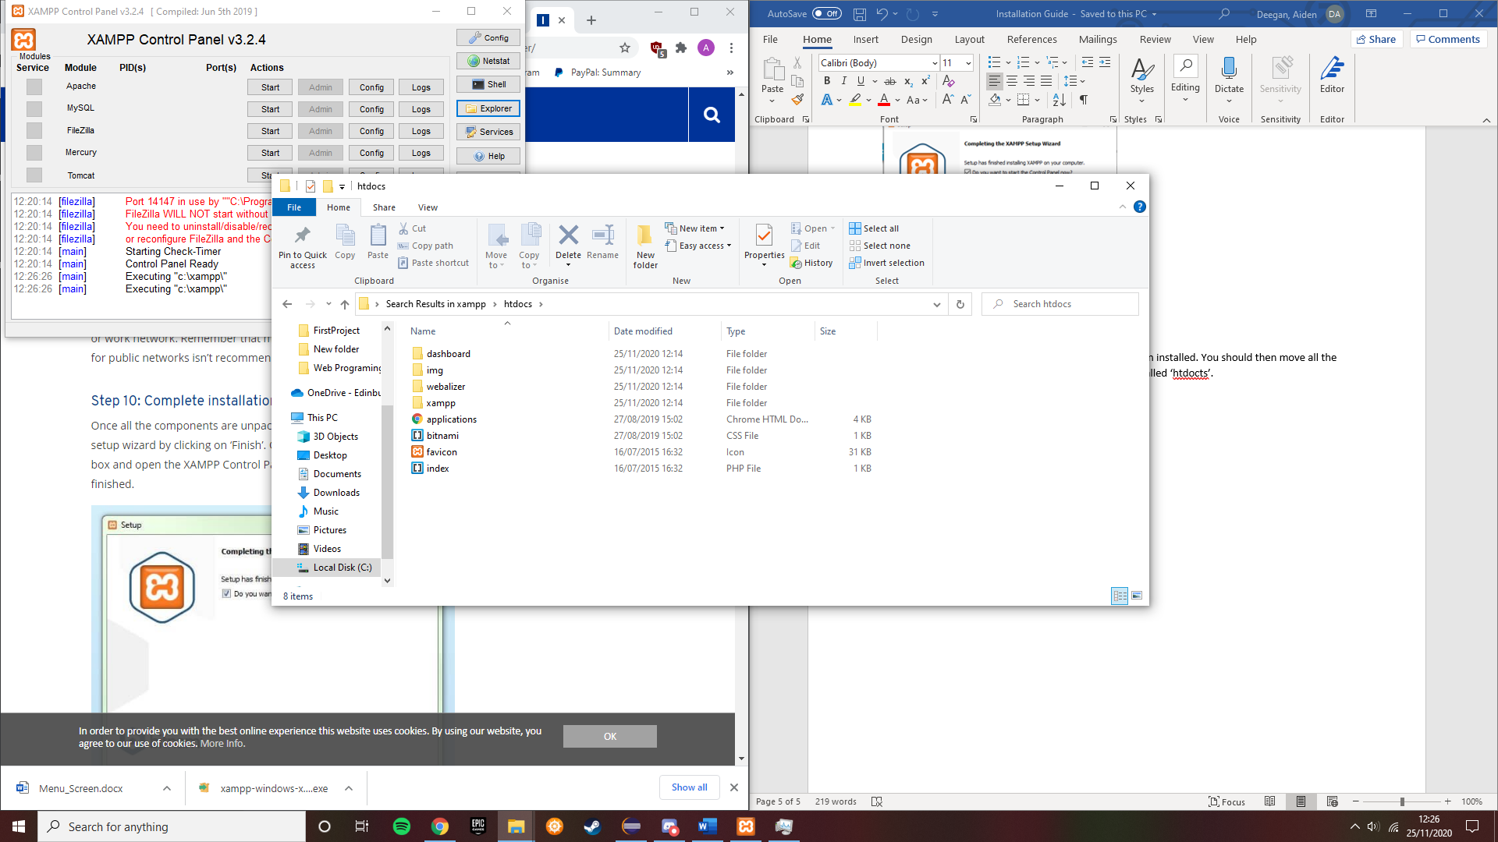

After everything is set up on XAMPP, go to any web browser. When this is done type in localhost/phpMyAdmin/ into the URL. Once this is done, open TopShooter.SQL into any word processor of your choice and copy to all this to the MySQL tab on phpMyAdmin.

